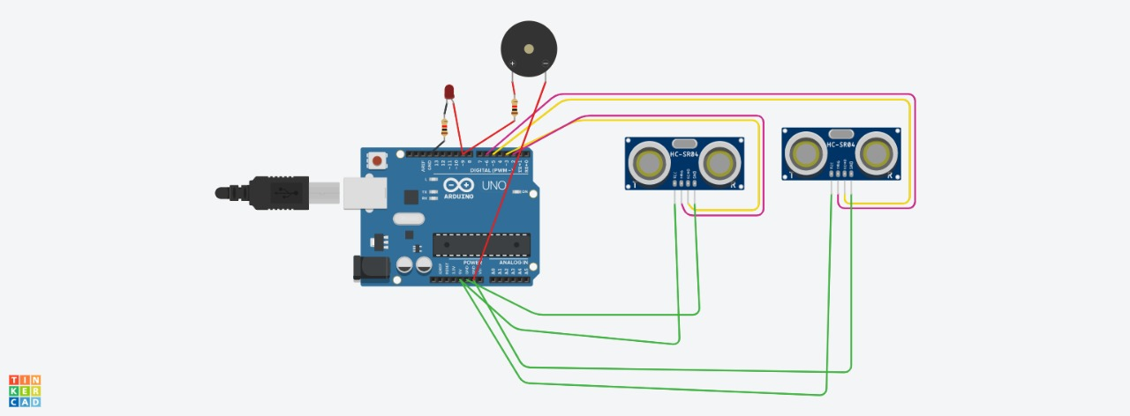
#include <Servo.h>

int pos = 0;

Servo servo1;
int trigPin =2;
int echoPin = 3;
int trigPin2 = 6;
int echoPin2 = 5;

void setup() {
Serial.begin (9600);
pinMode(trigPin, OUTPUT);
pinMode(echoPin, INPUT);
pinMode(trigPin2, OUTPUT);
pinMode(echoPin2, INPUT);
pinMode(9, OUTPUT);
servo1.attach(9);

}

void loop(){
ultra();
int duration, distance;
digitalWrite (trigPin, HIGH);
delayMicroseconds (1);
digitalWrite (trigPin, LOW);
duration = pulseIn(echoPin, HIGH);
distance = (duration/2)/29.1;

Serial.print(distance);
Serial.print("cm");
Serial.println();

if(distance > 100) {
digitalWrite (9, HIGH);
}
else {
digitalWrite (9, LOW);
}

int duration2, distance2;
digitalWrite (trigPin2, HIGH);
delayMicroseconds (1);
digitalWrite (trigPin2, LOW);
duration = pulseIn(echoPin2, HIGH);
distance2 = (duration/2)/29.1;

Serial.print(distance2);
Serial.print("cm");
Serial.println();

if(distance > 100) {
digitalWrite (9, HIGH);
}
else {
digitalWrite (9, LOW);
}
}
void ultra(){

for (pos = 0; pos <= 90; pos += 1) {

servo1.write(pos);

delay(15);
}

delay (1000);

for (pos = 90; pos >= 0; pos -= 1) {

servo1.write(pos);

delay(15);
}
delay (800);
}

